 |  |  | 

The 6th Regional Scientific and Technical Committee Meeting
For the SEAFDEC/UNEP/GEF Project on Establishment and Operation of
a Regional System of Fisheries Refugia in the South China Sea and the Gulf of Thailand
4-6 July 2022
SEAFDEC/Training Department, Samutprakarn, Thailand

COUNTRY INPUTS ON
RESULTS FRAMEWORK AS OF 30 JUNE 2022

The objective of this agenda is to update the progress at the country level by referencing the requirements that appeared in the Results Framework Template (see Annex 1). In addition, the country is requested to provide detailed information related to the establishment of fisheries refugia at the country level, as well as the management measures of each established fisheries refugia (see Annex 2).

ANNEX 1: Please update on Excel File_WP02B-Annex 1 attached herewith: (you can delete other columns, and maintain your country field)

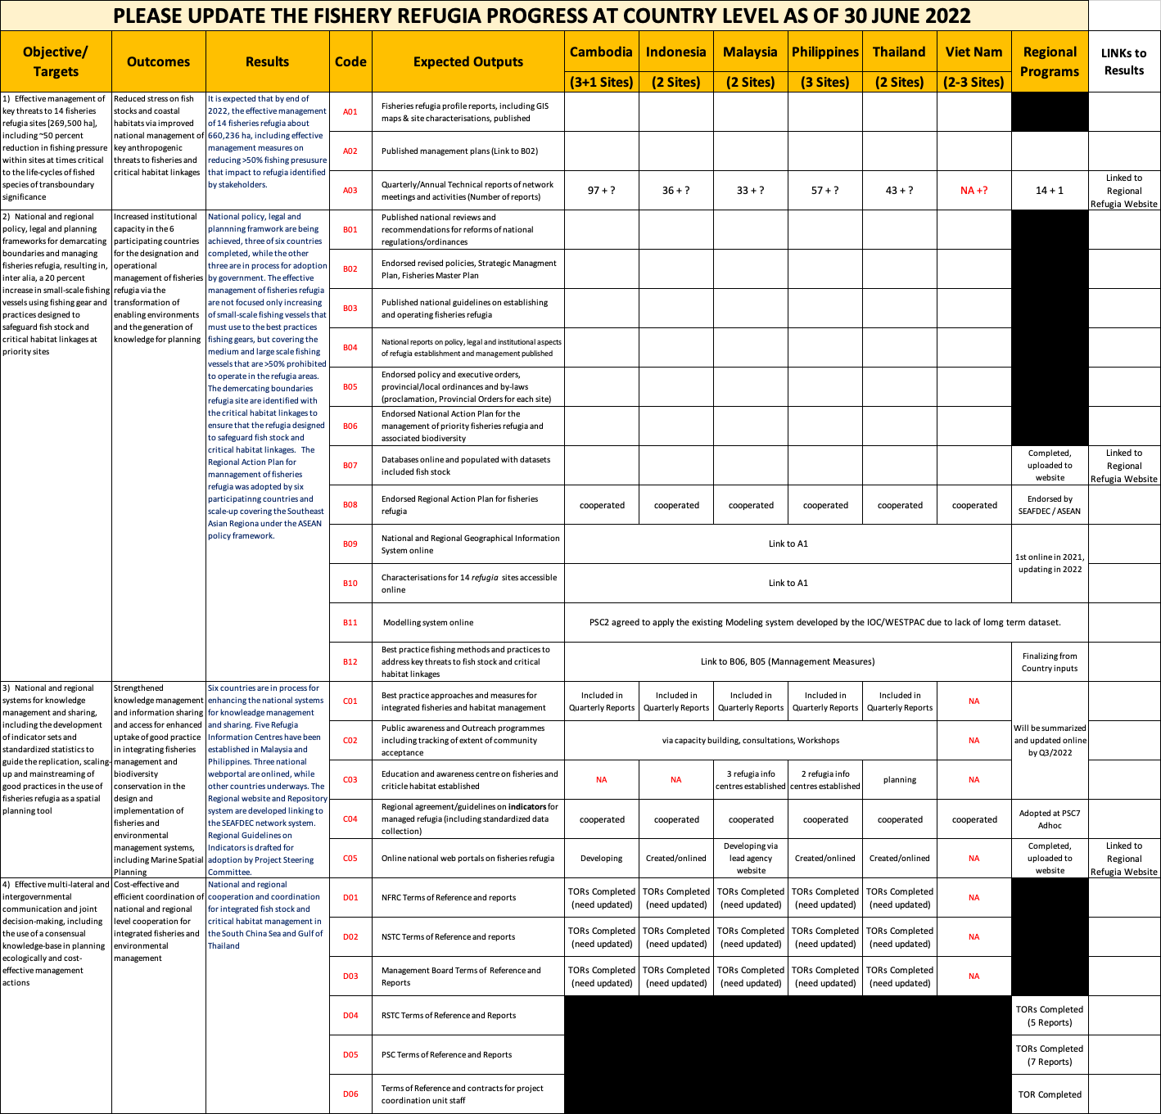

ANNEX 2: Please update the progress as of 30 June 2022 using the below template.

- Cambodia
 | Refugia site | Target species | Area (ha) | Status | Fishing Closure Period | Management Measures (details)
1 | Marine Fisheries Management including Blue Swimming Crab Refugia at Koh Po & Koh Tonsay Archipelago, Kep | Blue Swimming Crab,  Anchovy | 11,307 | Approved | May to July  ????-???? | - Ban crab fishing during the closure period?  - prohibited trawling ??
2 | Peam Krasob, Koh Kong | Indo-Pacific Mackerel | 1,283 | Approved | DD1/MM1-DD2/MM2
3 | Prek Thnaot, Kampot | Grouper | 284 | ????? | DD1/MM1-DD2/MM2
4 | Prek Sangke, Village, Tek Thlar Commune, Prey Nub District, Preah Sihanouk Province | Blood cockle | 116 | Approved | DD1/MM1-DD2/MM2

- Indonesia
 | Refugia site | Target species | Area (ha) | Status | Fishing Closure Period | Management Measures (details)
1 | West Kalimantan | Indian White Shrimp | 275,400 | ????? | DD1/MM1-DD2/MM2
2 | Bangka Belitung (islands) | Mitre Squid | ?????? | ????? | DD1/MM1-DD2/MM2

- Malaysia
 | Refugia site | Target species | Area (ha) | Status | Fishing Closure Period | Management Measures (details)
1 | Tanjung Leman, Johor State | Spiny Lobsters | 140,023 | ????? | DD1/MM1-DD2/MM2
2 | MIRI, Sarawak State | Tiger Prawn | 85,200 | ????? | DD1/MM1-DD2/MM2

- Philippines
 | Refugia site | Target species | Area (ha) | Status | Fishing Closure Period | Management Measures (details)
1 | Off Coron Islands, Palawan | Redbelly Yellowtail Fusilier | 1,242 | Final process | DD1/MM1-DD2/MM2
 |  | White-Tipped Scad | ????? |  | DD1/MM1-DD2/MM2
2 | Masinloc coastal area, Zambales | One-Stripe Fusilier | 624 | Final process | DD1/MM1-DD2/MM2
 |  | Frigate Tuna | ????? |  | DD1/MM1-DD2/MM2
3 | Bolinao coastal area, Pangasinan | Siganids | 263 | Final process | DD1/MM1-DD2/MM2

- Thailand
 | Refugia site | Target species | Area (ha) | Status | Fishing Closure Period | Management Measures (details)
1 | Off Trat Province | Indo-Pacific Mackerel | 154,600 | Approved | DD1/MM1-DD2/MM2
2 | Around Koh Sed, Surat Thani | Blue Swimming Crab | 900 | Approved | DD1/MM1-DD2/MM2

- Viet Nam
 | Refugia site | Target species | Area (ha) | Status | Fishing Closure Period | Management Measures (details)
1 | off Bach Long Vi Island, Viet Nam | Spiny lobster and shark ?? | ~????? | ~????? | ~?????
2 | off Con Dao Island, Viet Nam | Spiny lobster and Japanese eel ?? | ~????? | ~????? | ~?????

